**Ideation Phase**

**Empathize & Discover**

|  |  |
| --- | --- |
| Date | 19th June 2025 |
| Team ID | LTVIP2025TMID20428 |
| Project Name | FlightFinder |
| Mentor Name | Dr Shaik Salma Begam |
| Maximum Marks | 4 Marks |

**Empathy Map Canvas:**

An empathy map is a simple, easy-to-digest visual that captures knowledge about a user’s behaviours and attitudes.

It is a useful tool to helps teams better understand their users.

Creating an effective solution requires understanding the true problem and the person who is experiencing it. The exercise of creating the map helps participants consider things from the user’s perspective along with his or her goals and challenges.

**Example:**

Reference: <https://www.mural.co/templates/empathy-map-canvas>

**Online Book Shopping Application**

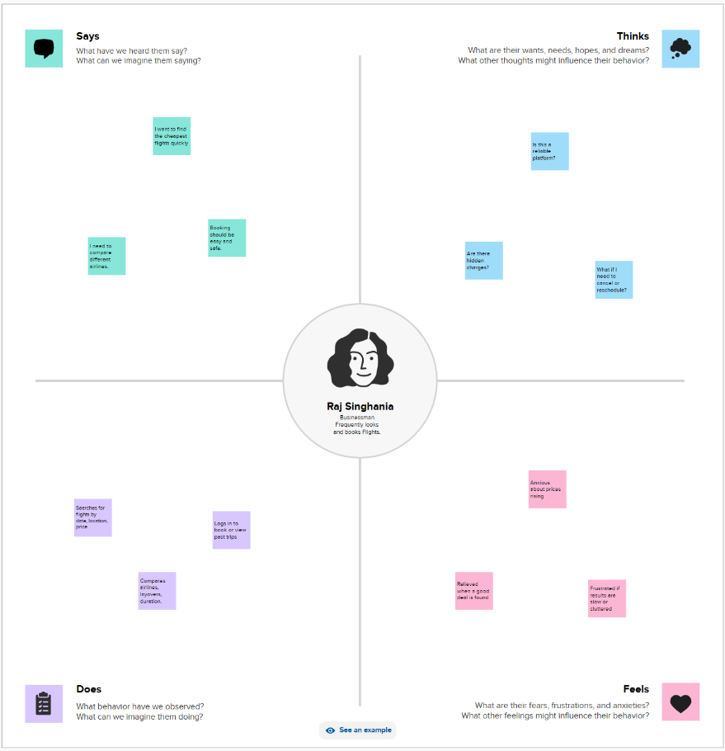

**User Persona:**

**Name**: Arjun  
**Age**: 28  
**Profile**: IT Professional, travels frequently for work and leisure  
**Goals**: Book affordable and convenient flights quickly  
**Tools Used**: Travel websites, apps (e.g., MakeMyTrip, Google Flights)

**Thinks**

* “Will I get the best deal if I wait or book now?”
* “Is there a hidden cost I’m missing?”
* “How can I trust the ratings or timings of this airline?”
* “Will I have good connectivity at layovers?”

**Sees**

* Confusing interfaces with too many options
* Pop-ups and ads on flight booking apps
* Inconsistent pricing across different platforms
* Offers with conditions written in fine print

**Says**

* “Why are there extra charges at the last step?”
* “This website takes too long to load!”
* “There should be better filters for timings and layovers.”
* “I just want something simple and fast.”

**Hears**

* “Use XYZ app, they give better cashback.”
* “Don’t book on weekends, prices are higher.”
* “Airlines often cancel cheaper flights last minute.”
* “Look out for hidden fees!”

**Pain (Frustrations)**

* Too many apps to compare
* Confusing policies about baggage, cancellations, and rescheduling
* Last-minute fare hikes
* Poor support from booking platforms

**Gain (Wants/Needs)**

* Simple and clean UI with quick filters
* Real-time fare updates and alerts
* Transparent breakdown of fees and policies
* Trusted reviews and route suggestions

**Tips for Team Discussion:**

* Refer to users in specific contexts like students, professionals, families, etc.
* Consider using different personas for deeper insights
* Use sticky notes or color-coded sections if drawing it on paper